

*Software Construction and Development*  
*LabTask 04*

Name : Muhammad Shamoil  
Section : BSSE – V – A  
Date: 20th Oct  
Submitted To : Sir Shareef

# Tomcat Setup

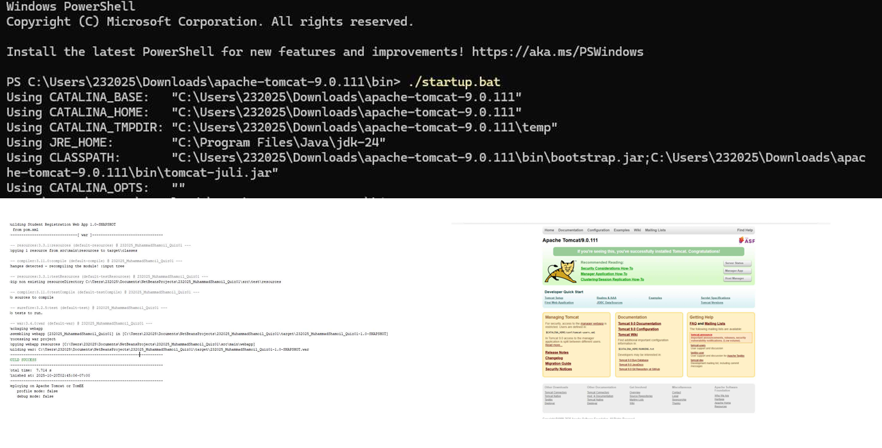

# App Snapshots

